CLIMATE CHANGE ADAPTATION

A manual for trainers

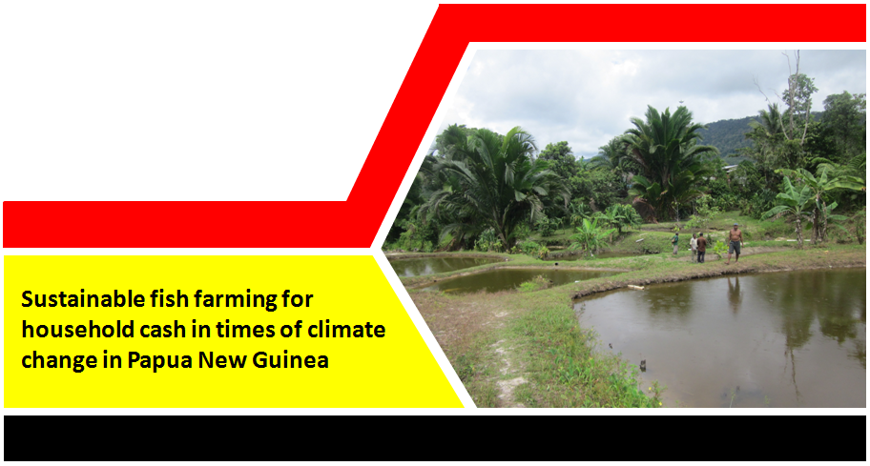

|  |  |
| --- | --- |
|  |  |

Supported by the European Union

**Maima Sine**

**National Agriculture Research Institute**

[**maima.sine@nari.org.pg**](mailto:Janet.pandi@nari.org.pg)

**14/12/2018**

**Acknowledgements**

**NARI gratefully acknowledges the generous support of the people of the European Union in the Action - Strengthening food production capacity and the resilience to drought of vulnerable communities.**

**The author thanks Mr. Arthur Roberts for his technical input and contribution towards development of this manual.**

**Table of Contents**

[Introduction 1](#_Toc532281656)

[Training Session Outline: 1](#_Toc532281657)

[Session 1: Know your fish- Fish production system 2](#_Toc532281658)

[Learning goals 2](#_Toc532281659)

[Introduction on fish and production system 2](#_Toc532281660)

[Fish and pond culture system 2](#_Toc532281661)

[Session 2: Fish Pond Plan and Construction 4](#_Toc532281662)

[Learning goals 4](#_Toc532281663)

[Introduction on Fish Pond Construction Plan 4](#_Toc532281664)

[Pond Construction 6](#_Toc532281665)

[Session 3: Feeding – Food, Water and Related Issue 11](#_Toc532281666)

[Learning goals 11](#_Toc532281667)

[Introduction on Feeding 11](#_Toc532281668)

[Session 4: Breeding and Reproduction 17](#_Toc532281669)

[Learning goals 17](#_Toc532281670)

[Introduction on Breeding 17](#_Toc532281671)

[Open Pond Spawning 19](#_Toc532281672)

[Session 5: Fish Keeping and General Welfare 22](#_Toc532281673)

[Learning goals 22](#_Toc532281674)

[Introduction on Fish Pond Management 22](#_Toc532281675)

[Session 6: Integrated fish pond farming with poultry 27](#_Toc532281676)

[Learning goals 27](#_Toc532281677)

[Summary 38](#_Toc532281678)

# Introduction

Climate change affects everyone and those responsible for information outreach and training provided to farmers and communities must ensure the right information is relayed to farming communities. Sometimes information on livestock farming is not correctly relayed to farmers and as results animals are mismanaged during drought. There are ways to convert livestock into beneficial gain during drought periods. A classic example is to farm a fish pond or an integrated farm of fish with duck and village chicken and create opportunity to gain more than one source of income and prepare resources for drought effect. Animal management is crucial in that regards as it provides cash income from sale of animals not needed, while some good breeders are maintained for recovery during post-drought. Cash earned from sale of animals can be used to purchase food item necessary to maintained family during drought period. The challenge is to train trainers of our farmers to understand this concept so that farming communities are aware and how they can deal with animal during the drought and be more resilient.

In this training manual, the emphasis is on improving the knowledge of our TOTs (Trainers of Trainees) in our Districts and Provinces to understand and equipped with improved farming practices and techniques/skills of raising village poultry and fish with the overall goal of up skilling and building capacity of farmers/trainers to be climate smart. The focus is on fish and poultry farming for production of eggs, meat (fish, duck and chicken) and for breeding foundation stock with the overall goal of ensuring that famers are able to still maintain production during climatic changes.

The manual covers basic aspects of fish and poultry production system. The training will be delivered in an interactive mode where TOTs and innovative farmers are involved with group discussions, farm visits, and demonstrations of basic skills in handling along with training notes.

## Training Session Outline:

The training will be covered in sessions, there are eight sessions covering theory, group discussions and participatory practical. Below is the training outline:

|  |  |
| --- | --- |
| Outline🡪 | |
|  | * Session 1: Know your Fish Farming * Session 2. Fish Pond Plan and Construction * Session 3. Feeding; Feed and Water * Session 4: Breeding and Reproduction * Session 5: General Welfare and Safety * Session 6: Integrated fish pond farming with poultry * Training Summary |

# Session 1: Know your fish- Fish production system

## Learning goals

|  |  |
| --- | --- |
|  | Farmers will 🡪 1. Understand fish production system in PNG  3. Know the advantage and disadvantage of different production system  4. Understand type of fish to farm in pond culture system |

## Introduction on fish and production system

Aquaculture is when you farm fish in fresh water or inland water such as rivers, creeks or lakes. Inland fish farming involve fish such as tilapia, carp, trout, barramundi, prawn etc... Fish farming has different production system and each type has different management system to suit their culture. The two main production systems used by most of our rural farmers are pond and cage culture system, the intensive culture system is recirculation aquaculture system or RAS and is sometimes called the tank culture system.

The focus of this training is to look at the pond culture system of fish farming and to understand how to manage the production stages of pond culture. This include; hatchery pond, juvenile pond, grower pond and breeder pond.

## Fish and pond culture system

Tilapia and carp are the most common type of fish farmed by smallholder farmers in Papua New Guinea. Pond culture is widespread throughout the country because people live in places where there are rivers, creeks, springs and swamps. Few farmers are extensively farming cage culture system where there is Dam such as Yonki in Eastern Highlands and Sirinum in Central. People also farm cage culture where there is lake and large swamps. Fish pond system also goes well with integrated farming with poultry and they have a mutual benefit and support each other in integrated farm unit.

|  |  |
| --- | --- |
|  | Different types of production systems in PNG The three different production system of fish farming are;   * Pond Culture Systems- farmers dig and construct earthen fish pond and divert or barrage water into the pond and culture fish, usually family unit or groups are involved in constructing a pond as it is more intensive labour and require collective effort. * Cage Culture Systems- Farmers construct cages using nets, floater, hanger and ropes and farm fish in floating cage, where fish are fed intensively to maintain production. Usually cage culture is semi-intensive needs extensive investment to continue good production. * Recirculation Aquaculture System (RAS) - This is an intensive system and requires greater input, the fish are reared in tanks and have a control water system with bio-filtrations system, water quality is monitored daily recycled back to the system and fish are fed daily. This kind of setup is usually happen to commercial farm with good investment for farming. |

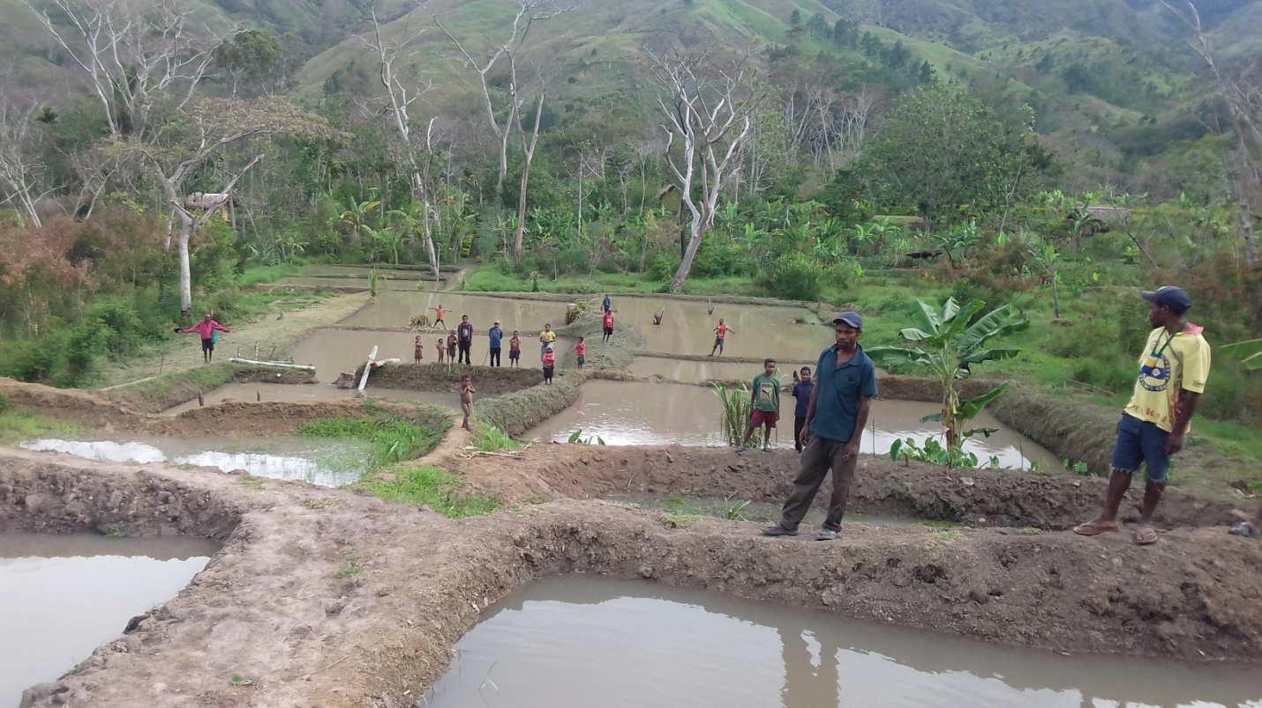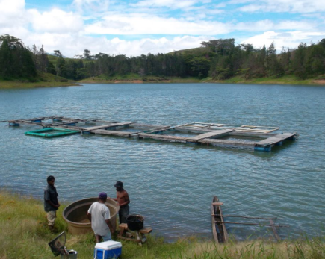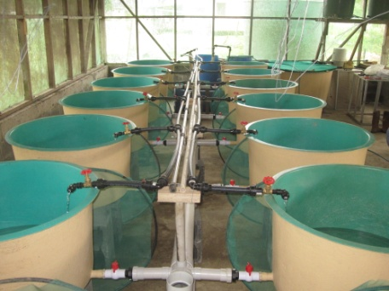

**RAS Culture System**

**Cage Culture Systems**

**Pond Culture Systems**

***Figure 1. The different production system of fish farming***

|  |  |
| --- | --- |
|  | Thinking together  * In group discuss the different production system and identify advantages and disadvantages * Discuss the type of fish species that is suitable to each type of production system * Record all answers, present their results and stimulate discussions on answers * Wrap up discussions by comparing answers and define smallholder fish farming production system   *Discussion materials: Flip chart, marker, note book, biro and attachment* |
|  | Working together Discuss together.   * Identify the most suitable fish species to be cultured with fish pond production system |

# Session 2: Fish Pond Plan and Construction

## Learning goals

|  |  |
| --- | --- |
|  | Farmers will 🡪  * Understand fish farm planning * Understand pond construction site selection * Understand soil and water requirement of pond construction * Understand how to construct a pond |

## Introduction on Fish Pond Construction Plan

A farmer considering culturing fish needs to consider a number of factors that may affect the success of the fish farm. Surveys for suitable sites should first identify strengths and weaknesses of physical characteristics such as**;** suitability of the soil,topography of the land,availability of good quality water,identifying goodmarket demands**,** proximity to markets**,** availability of needed inputs such as fertilizers and feeds and todetermine how existing and planned uses of the water supply area might contribute to or interfere with the farming enterprise.

### Careful planning of pond design

Before beginning the construction of a new fishpond, carefully consider the design. A properly designed and constructed pond will be easily managed and will last longer, saving extra work and bringing greater profit. Some specific design considerations to address include:

* The source of water used to fill the pond
* How water will be brought to the pond
* The type of soil available for building the pond
* The size, shape, and depth of the pond
* The slope of the pond bottom
* The height, width, and slope of the dykes
* The type of drainage system that will be used
* The layout (arrangement) of ponds used for different sizes of fish

When selecting sites for earthen fishponds, the main physical factors to consider are the land area, the water supply, and the soil. The following points should be kept in mind for each.

### Land area

* The land is relatively level. Steeply sloped land is not generally suitable for building ponds. A slope of about 1% is considered ideal.
* Determine that the area is large enough for your present plans and for any future expansion.
* The area should not be prone to flooding.
* The area should not be subject to pollution in runoff from adjacent land.
* If possible, the land must be slightly lower than the water source, so that the ponds can be filled by gravity

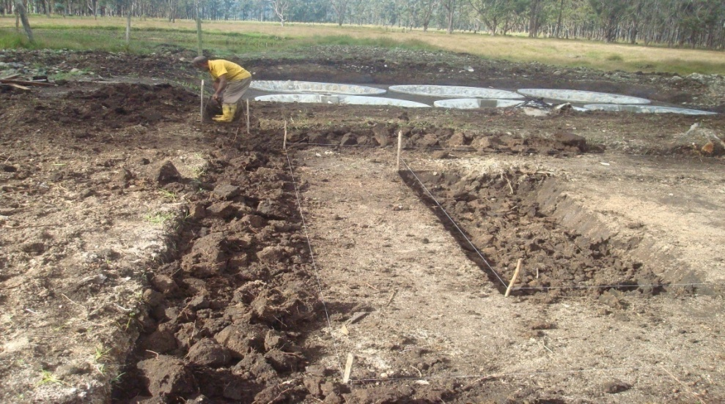

***Figure 2. Fish pond constructed on a land that is relatively level***

### Water supply

The most common sources of water used for aquaculture are surface waters (streams, springs, lakes) and groundwater (wells, aquifers). Of these, wells and springs are generally preferred for their consistently high water quality.

* The quantity and quality of water should be adequate to support production through seasonal fluctuations.
* Determine that the quality of the intended water source is good enough for fish to thrive in.
* A good water source will be relatively free of silt, aquatic insects, other potential predators, and toxic substances, and it will have a high concentration of dissolved oxygen.

|  |
| --- |
|  |
| ***Figure 3. A good water source from a spring or creek is good to divert to fish pond and is high in Oxygenated water*** |

* Find out if the quality remains constant throughout the year or if there are seasonal changes that result in poor quality at certain times.
* Make the final site selection based on both the quality and quantity of water available.

### Soil

Land must be properly assessed for quality soil for water retention, soil that has sand will allow water to escape and sip. Some tips on selecting a good soil:

* Land should be comprised of good quality soil, with little or no gravel or rocks either on the surface or mixed in. Areas with rocky, gravelly, or sandy soil are not suitable for pond construction.
* The soil should be deep, extending down at least 1 metre below the surface. There should not be layers of rock lying close to the surface. Soils in the area where ponds will be built should have clay layers somewhere below the surface to prevent downward seepage. Soil that will be used to build the dykes must contain at least 20% clay so the finished pond will hold water throughout the growing period.
* Some soil with are higher clay content—preferably between 30 and 40%—should be available nearby. It will be used to pack the core trenches in the dykes.

|  |
| --- |
|  |

## Pond Construction

Pond construction is labour intensive and require family unit to complete a construction. The construction of pond must use the design obtained from the site planning and assessment.

|  |  |
| --- | --- |
| Steps in building a fish pond | |
|  | Once you have designed your pond there is a logical sequence of steps that you should follow to build it. These are:   1. Survey the land 2. Clear all vegetation from the site 3. Remove the topsoil from the site 4. Determine pond, drain pipe, and supply canal elevations 5. Peg out the pond, including core trenches, dyke tops, and dyke toes 6. Dig core trenches and pack them with good soil 7. Excavate the pond area 8. Build the dykes 9. Install the drainage system 10. Install the water supply system |

|  |  |
| --- | --- |
| 1. Survey the land |  |
| 1. Clear all vegetation from the site |  |
| 1. Remove the topsoil from the site |  |
| 1. Determine pond, drain pipe, and supply canal elevations |  |
| 1. Peg out the pond, including core trenches, dyke tops, and dyke toes |  |
| 1. Dig core trenches and pack them with good soil |  |
| 1. Excavate the pond area |  |
| 1. Build the dykes |  |
| 1. Install the drainage system |  |
| 1. Install the water supply system |  |

***Figure 5. Diagram showing steps in constructing a fish pond (source: Koroba, HELA)***

|  |  |
| --- | --- |
|  | Thinking together  * Agree on a suitable design for pond construction * Discuss the importance of site assessment/land survey and understand the important requirement of pond construction   *Discussion materials: Flip chart, marker, note book, biro and attachment* |
|  | Working together Participatory practical on pond design application:   * Apply designed pond layout onto field preparing for construction   *Materials; peg, string line level, spade, knife and tape measure* |

# Session 3: Feeding – Food, Water and Related Issue

## Learning goals

|  |  |
| --- | --- |
|  | Farmers will 🡪  * Understand nutrient requirements of fish * Understand how to utilize locally available feed resources * Understand how to formulate supplementary feed * Explain what the fish needs in its food |

## Introduction on Feeding

Feed is an important component of fish production and it must be given priority, feed cost alone cater for 70-80% of fish production cost, if a farmer does not have capacity to meet feed demand for fish must carefully assess his/her plan before starting a fish pond culture, fish require a very high protein and a balance diet for optimum growth.

|  |  |
| --- | --- |
| Nutrient requirements | |
|  | Nutrient requirements of fish are defined in terms of **energy, protein, minerals and vitamins**. The primary source of energy in feeds is carbohydrate, but this is dependent on the oil and fibre content. Carbohydrates are represented by the starch as in cereal by products (millrun, rice bran, corn meal) and root crops (cassava and sweet potato). Oils and fats provide high sources of energy in fish feeds. Fat in the meat of fish reflect the composition of the oil fed in the diet. Essential fatty acids are required for growth of some fish such trout and barramundi. Energy requirements of fish in diet is 14-17MJ/Kg  Balanced feeds are normally formulated to set energy levels, with all other nutrients such as protein, amino-acids, vitamins and minerals being included in the diet at levels which will meet the requirements of the fish. A supply of amino acids is necessary for growth and reproduction. The amino acids must be available within the protein component of the feed, and are specified with the actual protein level. Because of the high requirement for essential amino acids by fish, it is difficult to meet the requirements. Therefore commercially available amino acids in pre-mixes are often included. Ingredients that contain high protein level are fishmeal, meat & bone meal, poultry offal meal, blood meal and soybean meal. Protein requirements for fish varies from species, carnivorous fish has high requirements (40-60%CP) while omnivorous and herbivorous species such tilapia and carp less requirements (25-36%CP)  Vitamins are classified as fat-or-water soluble. Fish are dependent on the feed as a source of fat-soluble vitamins (vitamins A, D, E and K). The inclusion of vitamin is essential for health and production. Minerals are classified into macro-elements and microelements and are often included in the commercial pre-mix. Macro-elements are phosphorous, calcium and sodium. Potassium is also required but is available in most feed ingredients. Phosphorous is generally deficient in plant ingredients and must be supplemented from animal or inorganic sources. Supplementary calcium is often added as limestone. Sodium is available in common salt.  **Helpful tips**  These are the nutritional requirements for fish to support growth, reproduction, disease resistance, physical strength and internal temperature   * Proteins * Energy * Vitamins * Minerals * Water   Lack of any of these nutrients will lead to disease, abnormal change or organ functions and slow growth. |
| Feed available and how to process and use? | |
|  | Manufactured fish feeds are not widely or readily available in PNG. Where manufactured feeds are available, they might be found in one or more of the following forms:   * Mesh or powdered form * Crumbles * Pellets (dry, wet, floating and sinking)   Some farmers are successfully using feeds they have mixed for themselves. They use locally available ingredients to make feed. Starchy ingredients such as cassava and sweet potato are produced on farm and protein ingredient by-products are purchased and mixed with either cassava or sweet potato to make fish feed that are nutritionally balanced.  Feed processing usually includes a number of steps, including, cheaping/grating, sundry, grinding/milling, mixing, binding together, fat coating (oil), drying/cooling, crumbling, and bagging. Most on-farm feed preparations are made in small quantities, using improvised machinery that is operated either manually or mechanically. Feed ingredients can be hand ground/milled. The ingredients are then mixed in a hand-operated mixer. After preparation, feeds can be made into pellets using a pelleting machine or mincer. |

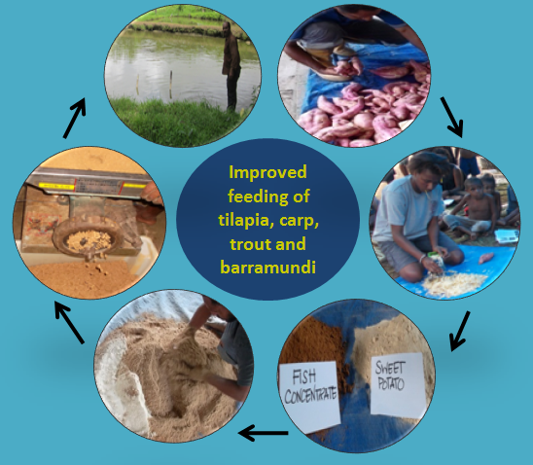

***Figure 6. Using locally available food resources to process and formulate a simple supplementary diet for fish***

|  |  |
| --- | --- |
| Rations | |
|  | Rations will change with requirements of fish sizes. Young fish need rations that are rich in protein, while growers and breeders require optimum to maintain growth and performance. Some examples of rations are given in Table 2.  The following are some important things to remember about rations for fish:   * Feed mixture should be thoroughly mixed and made as crumble for small fish and pellet form for big fish. |

|  |  |  |  |  |
| --- | --- | --- | --- | --- |
| Age of fish | Carbohydrate | Plant protein | Animal protein | Minerals |
| Fry-Fingerling | 5 parts | 2 parts | 3 part | 0.3 part |
| Grower | 6 parts | 2 parts | 2 part | 0.3 part |
| Breeder | 7 parts | 2 parts | 1 part | 0.50 part |

***Table 1. Feed formulation rations and feed requirement of tilapia and carp fish according to different sizes***

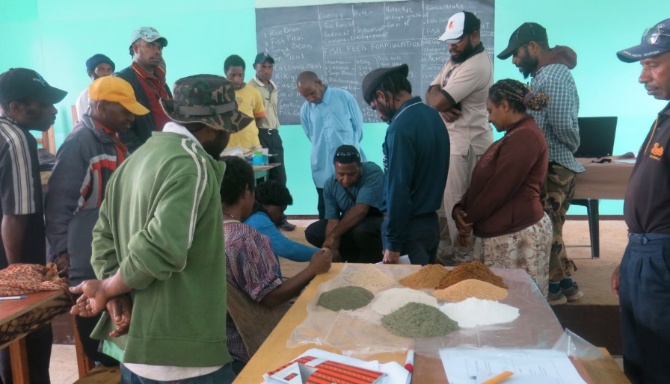

***Figure 7. Using locally available food resources to formulate a simple supplementary diet for fish (picture; farmers in Koroba HELA)***

|  |  |
| --- | --- |
| Storage of feed and how to feed your fish | |
|  | To ensure good quality and palatability, fish feeds should be stored in cool and dry stores. Avoid buying excess feed that may expire before its use.  An understanding on the natural feeding of fish is important in order to produce: An acceptable and nutritionally adequate diet. A proper feeding regime is adopted to ensure optimal growth and survival of the fish. You must know how many fish you have in your pond to properly calculate how much feed to give.   * Feed can be fed all at once or divided into two equal portions given in the morning and in the evening.   For better feeding efficiency, weigh a representative sample of your fish every second week, using their actual weight to determine the amount to feed rather than an assumed weight.  Keep the following points in mind while deciding when to feed your fish each day:   * Tilapias have small stomachs and often browse all day long. * The best time to provide supplementary feed is between 10 a.m. and 4 p.m., when the water temperature and dissolved oxygen are reasonably high. * It is advisable to feed from the same position and time each day for each pond. The fish soon learn when and where they can expect a good meal. * The feeder must be a reliable and dedicated person. * Do not overfeed. Too much food will not be eaten but will decay and will use up oxygen during decaying process. * Monitoring the dissolved oxygen of the pond regularly. Ponds with low DO concentrations, fish will eat less and they will not convert food to flesh efficiency. * Do not feed the fish for about 24 hrs before harvesting or transporting. When the fish eat, they void the waste into the water. Combination of food and wastes makes the water turbid and increases the stress that is already placed on fish by the breeding and harvesting process. * Always have routinary pond cleaning and stock inventory. Aquatic macrophytes remove inorganic nutrients and limit phytoplankton growth. * Keep a daily record of feeds given and of fish mortality. It would determine the efficiency of a feeding program and would help one to interpret if the farm was successful or not. * Avoid overstocking the pond. It deteriorates water quality, increase metabolic waste build up and lead to poor utilization of supplemental feeds. |

|  |  |  |  |  |
| --- | --- | --- | --- | --- |
| Time since stocking (months) | Assumed size of fish (grams) | Protein Req (%) | Amount to feed per day/fish | |
|  |  |  | *Formulated diet* | *Supplements + fertilised pond* |
| 1–2 (Fries) | 1–15 | 35-40 | 15-30% of fish BW | 10-15% of fish BW |
| 2–3 (Fingerlings) | 15–30 | 30-35 | 10-15% of fish BW | 5% of fish BW |
| 3–5 (Juvenile) | 30–100 | 28-32 | 10-15% of fish BW | 5% of fish BW |
| 5–8 (Grower) | 100–300 | 25-30 | 10-15% of fish BW | 5% of fish BW |
| 8 plus (Breeder) | Over 300 | 28 | 5% of fish BW | 3% of fish BW |

\*BW: bodyweight

***Table 2. Daily feed rations (per fish), determined either according to the time since stocking or the present size of the fish. The amount of feed shown should be multiplied by the number of fish present in the pond.***

|  |  |
| --- | --- |
|  | Thinking together  * Discuss in groups and identify locally available food resources that can be used for fish diets * In groups, allocate the identified food resources into their nutritional groups of energy, protein and vitamins/minerals * Discuss the importance/short-comings of this food resources application on farm   *Discussion materials: Flip chart, marker, note book, biro and attachment* |
|  | Working together Participate together.   * Formulate a simple supplementary diet for fish based on the formulation ratio given in table 2. |

# Session 4: Breeding and Reproduction

## Learning goals

|  |  |
| --- | --- |
|  | Farmers will 🡪  * Understand the background of breeding and what you want with your fish * Know how to select good breeding male and female fish * Understanding issues affecting survivability of your fish |

## Introduction on Breeding

There are many fish species that are suitable to farm in PNG, the type of fish to farm depend on the many factors such as; environment, location, farmer technical and financial capacity. Choosing the right breed for your stock solely depends on your needs. There are many fish breeds in PNG and some common ones farmed around the country are: Tilapia, Carp, Trout and Barramundi.

Examples of some fish species found in PNG;

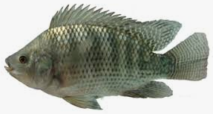 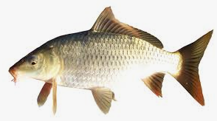 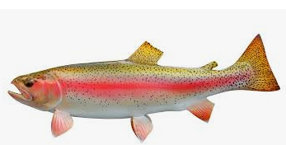 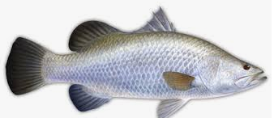

Gift tilapia Common Carp Rainbow Trout Barramundi

|  |  |
| --- | --- |
| What is breeding? | |
|  | Breeding is the selection process or mating of fish to generate more fish. Natural breeding occurs naturally without any intervention from the farmer. Artificial breeding or selection occurs when a farmer is controlling the mating process with a breeding goal in mind. There are basically two types of breeding;   * Cross-breeding is the mating of chickens that are not related whilst * In-breeding -is the mating of related fish, e.g. a mother and son, father and daughter, or brother and sister.   In-breeding causes problems such as poor growth and low productivity, susceptibility to disease, lameness etc. To avoid in-breeding, change breeders every 12 months. Broodstock selection and management The key to good breeding management is obtaining and maintaining good quality bloodstock. Maintaining good quality breeders and preventing introduction of other species (most especially Tilapia mossambica) into the brood pond to avoid genetic contamination, eliminating fish that have questionable characteristic; avoiding random introduction of breeders from different sources, and draining the brood ponds completely and eliminate all stocks during pond conditioning to avoid inbreeding depressions. Below are broodstock selection and maintenance requirements;   * Select quality broodstock to improve fish production on your farm. * Choose pure quality stocks and do not allow them to crossbreed with other strains to preserve their genetic quality. * Teach your workers the importance of preventing genetic contamination. * Initially you may have to collect your broodstock from the wild, whereas later you can select them from your own ponds or purchase them from other farmers or organisations. * If buying your fish stocks from others buy them only from reliable and established sources and avoid introducing breeders from no accredited sources. * Use brood fish that are mature but not too old; for catfish and tilapia they should be at least one year old but not more than three years old (> 100 g for tilapia). * By using larger brood fish, you can easily identify the original stock after each production cycle. * You can use the same stock repeatedly, depending on their performance, but should adopt a culling/selection process to eliminate undesirable stock. * Always eliminate fish that have questionable characteristics by examining breeders carefully when re stocking after each cycle. |

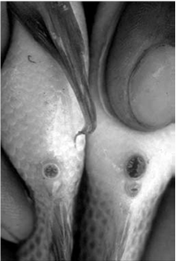 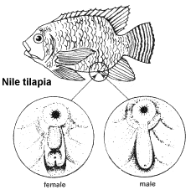

***Figure 8. Young male and female fish can be distinguished when they reach about 20g in weight. On males (left) the genital papilla is larger and more distinct than on the female (right).***

|  |  |
| --- | --- |
| Breeding cycle | No. of days |
| Egg laying | 35 days |
| Brooding | 21 days |
| Resting | 14 days |
| Total number of days for a cycle | 70 days |

***Table 3. Timetable of one complete breeding cycle of tilapia***

## Open Pond Spawning

The pond spawning utilizes small backyard hatcheries as well as large commercial hatcheries. The pond serves both as spawning and rearing pond. Breeders are stocked into the ponds and allowed to spawn naturally at controlled interval. The fingerlings are collected on the 30th day after stocking up to the 45th day which is also the total collection (draining) of the pond. Fingerling harvested ranges from 15g to 30g. The weight of breeders ranges from 100 grams to 1,000 grams.

|  |  |
| --- | --- |
| Breeding behaviour | |
|  | Understanding the behaviour of fish is import to manage and breed fish. Below are some important tips on breeding:   * Mature tilapia can spawn about once a month all year round if temperatures remain above 22°C; below 22°C spawning will be seasonal. * In actively breeding populations of tilapia, much of the energy resources of females are tied up with reproduction, either while producing eggs or during mouth brooding; this means that the growth rates of males are much higher than females. * Males make nests and attract ripe females to the nest with courtship displays. * The female lays eggs in the nest, where they are fertilized by the male and immediately picked up in the mouth of the female. * Males will continue to court other females, while the female that has just spawned retreats away from the nest to incubate the eggs. * Males play no part in parental care and can mate with many females at a time; therefore sex ratios in breeding ponds can be as high as seven females to one male. * Eggs hatch in the mouth of the female after about five to seven days (depending on temperature) and the hatchlings remain in the mouth while they absorb their yolk sacs. * Tilapia fry start swimming out of the mouth to feed, but return to the mouth at any sign of danger. Once the fry have become too large to fit in the female’s mouth, they become totally independent and move to warm, sheltered water such as near the edge of a pond. * Tilapia eggs are relatively large, producing large fry. * Removing the eggs or fry from a brooding female prematurely will increase the frequency at which the female will spawn. * Eggs are stimulated to develop once the previous batch of offspring is released, so a female will return to spawn after a recovery period of four weeks or less. * Typical brood sizes are 100-500 fry; larger females have bigger broods. |

|  |  |  |
| --- | --- | --- |
| Stocking methods of breeders | Sex ratio  (male: female) | Stocking of breeders |
| Weight method | 1:3 | 100-200kg/ha |
| Set method: 1 set  = 1 male :3 female | 1:3 | 1 set per 6m² |
| Number per unit area | 1:3 | 1 breeder/2m² |

***Table 4. Stocking density and breeder mating ratio***

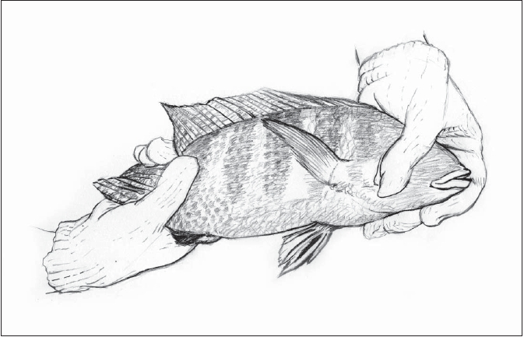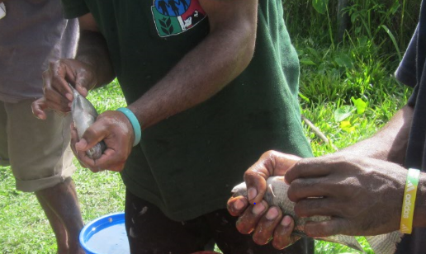

***Figure 9. How to handle fish with care and ease (source: Labu)***

|  |  |
| --- | --- |
| Factors leading to low Productivity in fish farming | |
|  | Husbandry management associated with the types of production system used has influence productivity, if farmer has poor management to farm production system will result in low productivity. Some of these factors are;   * Poor nutrition * In-breeding within the stock * Breeders are not maintained properly * Lack of a good plan for production and sales * Poor or lack of housing (Prone to or vulnerable to elements and theft) * Poor understanding and knowledge on how to or methods in the control and treatment of diseases |

|  |  |
| --- | --- |
|  | Thinking together Together discus on;   * Breeding behaviour of fish * How to select a good breeder * Issues that affects low productivity of fish |
|  | Walking together Visit to the farm;   * Identification of gender/sex |

# 

# Session 5: Fish Keeping and General Welfare

## Learning goals

|  |  |
| --- | --- |
|  | Farmers will 🡪  * Understand the importance of managing fish * Know how to prepare fish pond to stock fish * Understand fish handling * Understand water quality and how to manage * Understand health issues of fish |

## Introduction on Fish Pond Management

In fish farming enterprises, efficient operation and high production can only be achieved if ponds are properly managed. Management activities begin with the preparation of the pond for the fish and continue with stocking and feeding the fish, ensuring that water quality remains high throughout the culture period, taking measures to prevent invasion by predators and the occurrence of diseases, and harvesting the fish. An important ancillary management practice that should never be overlooked is keeping good records of expenses and income and of all activities and events associated with the pond or farm, so that this information can be used to improve operations in the future.

|  |  |
| --- | --- |
| Preparing your fish pond for stocking | |
|  | Prior to stocking your fishpond, whether it is a newly constructed pond or is a pond that you have just harvested, there are certain things you should do to prepare the pond for the next crop of fish. Follow the steps below to properly prepare your pond for stocking.   * For an old pond, drain all water from the pond and allow it to dry for a period of 14 days(figure 6) * Apply lime to the pond bottom and dyke slopes, if it is in a dry area no need to apply * Apply organic fertilizer to the pond before filling it with water (50g dry matter /m² area per week) * Fill the pond with water and if need be fertilise the pond for 14 days to grow algae * Stock fish into the pond, make sure required number of fish are in the pond (Unit stocking capacity=1 m²: 3 fish) |

**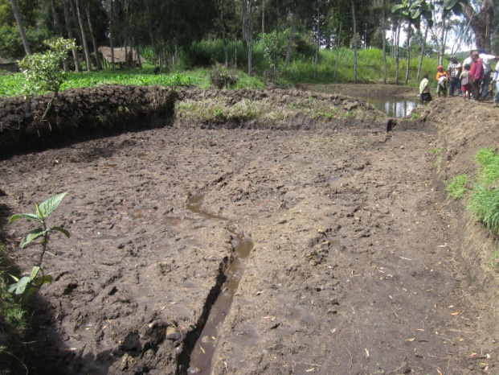** **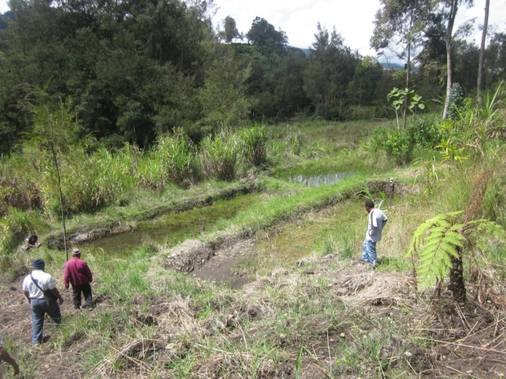**

***Figure 10. Drying the pond bottom helps kill potentially harmful organisms in the soil and speeds the breakdown of excessive organic matter (a beneficial process) that remains after previous crops of fish (source: Alken-Tambul).***

|  |  |
| --- | --- |
| Stocking your fish pond | |
|  | To get a good size of marketable (250g and above) fish it’s necessary to stock the pond with the correct number of fingerlings. Stocking too few fish may result in fast growth and large fish but this isn’t an economical use of the pond. However, stocking too many fish will result in slow growth and a large number of very small fish.    ***Figure 11 Left: Stocking too many fish results in a large number of very small fish. Centre: Stocking too few fish results in a few very large fish, but the pond space is not fully utilized and more fish could have been produced for the same cost. Right: Stocking just the right number gives many large, marketable fish.***  Safe handling and movement of fish:   * Stop feeding your fish one to two days prior to moving them. * Handle fish only during the cool parts of the day, preferably early in the morning. * Use appropriate nets, seine, buckets, tub and handling equipment to handle fish . * Keep fish in water during all stages of moving from one place to another. * Do not crowd the fish too closely in seines, dip nets, tubs, or transport tanks. * Move fish to their next location as quickly as possible; do not leave tubs or buckets of fish out on the pond bank for a long time, especially on hot days. * When putting the fish into a pond, take some time to equalize the water temperature in the transfer container (plastic bag, bucket, tub, etc.) with that of the pond water. This can be done by floating the transfer container in the pond water for approximately 15 minutes prior to releasing the fish. * You can also gradually mix the pond water into the transfer container; this has the advantage of equalizing not only the water temperatures but also other water chemistry differences that may exist. * Whenever possible, provide a spray or gentle flows of clean, fresh water to fish that are crowded together during handling. * Clean all of your fish handling equipment thoroughly after each use. This can be done by thoroughly rinsing it in clean water, picking all debris, fish, or other materials out of it, and drying it briefly in the sun. This helps preserve your equipment and minimize the spread of fish diseases.     ***Figure 12. Plastic fish transportation bags should be floated in the pond long enough to equalize water temperatures prior to releasing the fish*** Managing Water Quality in Your Pond Good water quality must be maintained if fish are to remain healthy, grow well, and give you a good crop in a reasonable amount of time. To maintain water quality, farmers must monitor pond conditions every day, taking note when things do not appear normal or if fish are behaving in unusual ways. Following are some water and soil quality characteristics to be concerned with and some methods to ensure that pond conditions remain good.   * Make sure there is sufficient water flowing into your pond (1000ml/seconds) * Your goal should be to keep Dissolved Oxygen (DO) at 4 mg/L or higher by: * Promoting and maintaining a good phytoplankton bloom through fertilization; however, do not over fertilize your pond. * Stocking your fish at the recommended rates. * Feeding your fish at the recommended daily rates and avoiding overfeeding, which wastes feed and may compromise DO levels. * The pH of pond waters should be maintained between the optimum limits for fish, i.e., between 6.5 and 9.0. * As much as possible, water temperatures should be maintained within the optimum ranges of the species being farmed * Ponds should be provided with adequate supplies of the nutrients (pond fertility) needed by pond organisms to ensure good health, reproduction, and fast growth of the fish. * Maintain a plankton density (algae bloom) that allows you to see about 30-45 cm into the water (The depth where you can just see the palm of your hand if you extend your arm into the water up to your elbow)    Preventing stress, parasites and disease ***Figure 13. You can use your hand to check visibility (phytoplankton density, fertility) in a pond.***  Monitor your fishpond and observe the behaviour of your fish at least daily, looking for any of the following signs of stress and/or disease:   * Many fish “gulping air” (“piping”) at the water surface and crowding around an inlet of freshwater * Loss of appetite by fish and individually swimming erratically and apart from the rest * Individual fish of unusual colouration—often very dark in appearance and swimming in circles (“whirling”) * Retarded growth and distended stomach   External parasites visible on the fins, body (perhaps protruding from under scales), or gills of fish; parasites (worms) visible on/in internal organs   * Excess mucus on skin and cotton- or wool-like growths (fungus) on the skin surfaces * Peeling skin, ulcers, lesions, and erosion of fins.  Preventive measures Practice the following measures to reduce stress and avoid the development of parasites and diseases in your fishpond:   * Dry your pond after each culture cycle. * Manage soil pH or water alkalinity. * Keep weeds cut back in and around your pond. * Control populations of birds, reptiles, snails, frogs, and wild fish around your fishpond. * Stock only with healthy fish obtained from a known source — inspect fish purchased for stocking before taking delivery of them. * Quarantine any fish exhibiting strange behaviour or an unusual appearance.  Controlling predators around your pond Predators, especially birds such as kingfishers, pelicans, and herons, can cause massive crop losses for you, perhaps without you even knowing there is a problem until you harvest your fish.. Some basic steps to minimize these problems include:   * Keep grasses on dykes and around ponds cut low. * Install covered hapas in your pond for rearing very young fish. * Construct a low barrier around ponds to keep small land animals out. * Stretch netting over ponds to keep birds out. |

|  |  |
| --- | --- |
|  | Thinking together  * Discuss Importance of managing fish * Why is water quality important |
|  | Walking together Walk together to Labu Aquaculture facility and observe pond management system.   * Fish pond management assessment |

# Session 6: Integrated fish pond farming with poultry

Fish integrated farming looks at the best way possible to assist fish farming rural communities to use natural resources as inputs to improve their fish and livestock through the means of integrating their fish ponds with livestock. In our case, we will look at chickens and ducks as our integrated approach with fish ponds.

## Learning goals

|  |  |
| --- | --- |
|  | Farmers will 🡪  * Understand the linkages between fish and poultry integrated farming * Know the advantages into the integration of farming fish with ducks or chickens * Understand the processes involved in recycling organic wastes through their fish ponds * Basic understanding into the setting up a fish and poultry integrated farming unit * Appreciate the utilization of under used resources as inputs into your fish farming enterprise |
|  | What is fish pond integrated farming? It’s combining the farming of fish with one or two farming activities that either share a direct link or have benefits from the other. The idea with fish integration is looking at the farming activities and identifying the natural resources that can be used back into the fish farm. A clear example is food, fodder or feed spillages, manure droppings that are readily available to use as feed or fertilizers for fish ponds.  When we have that thought clearly seen, we can appropriately link these natural resources into our integration and other farming activities.  Since we know what integrated fish farming is, let us see what the idea is all about by using fish integrated with ducks or chickens |

### Understanding the Processes

The diagram helps in identifying the processes involved in a fish pond integrated system and the linkages each farming activities provide. For example, green fodders, left over kitchen food like sweet potato are given to animals. Much of the food or fodder are not utilized by the animals, and end up in the excreta. In addition, part of the animal feed will not be eaten. Both the excreta and leftover feed can be used in the fish pond as food or fertilizer instead of being wasted. In turn, the nutrient rich water drained from the pond can be used in elsewhere. The more effective use of resources reduces waste but also the reliance on supply of fertilizer or feed from outside the household. This helps to growing fish without the use of feed

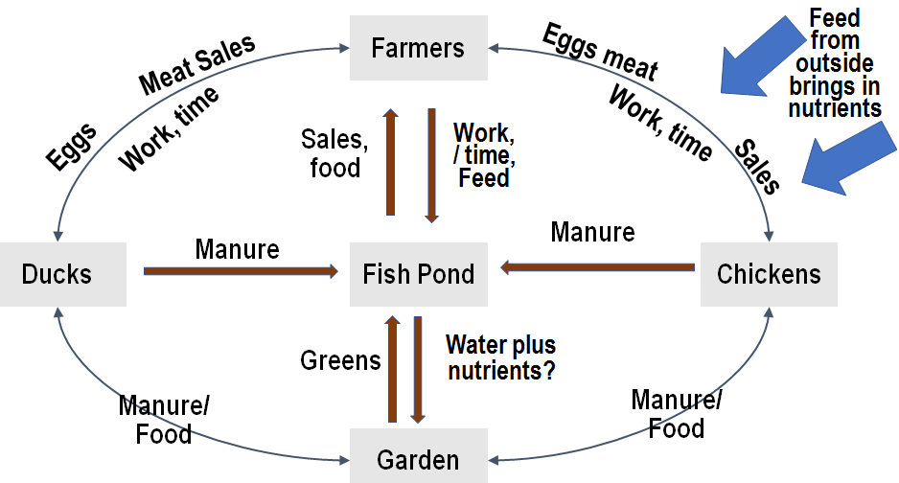

***Figure 14. Integrated system linking fish pond, poultry and garden and their relationship***

|  |  |
| --- | --- |
|  | Thinking together 🡪Why integration? Why Combine? Integration provides an alternative approach into farming fish with other farming practices. There are good number of reasons why integration can contribute to rural communities for food security and even income. Here are a few points to consider;   * Limited land space * Limited arable land to expand farming activities * Limited labour * High soil moisture conditions * Unable to access feed for fish and even livestock   These reasons may help in understanding integration has a useful approach in taking two activities like fish farming linked with poultry farming. Turning natural resources into farm inputs basically improves productivity with limited resource use in rural communities. |
|  | Working together🡪 Let us look at some examples Remember that integration is a combination of two or more farming activities that share benefits. We should also remember that integration can be done for example with village gardens and other useful purposes. There are lots of ways integration can connect with fish farming, however, we will look at ducks and chickens and get into some details. But firstly, let us look at the pictures below having in mind the below questions.   * What did you notice in the pictures? * What are they housing? * Are there any similarities in the house design? * What do you think is being housed? * Why is the housing built in that way? * What is happening to the water? * Would you be able to explain what is being used or being linked in this type of fish integration? |

### Have a look at the pictures, what do you notice?

|  |  |
| --- | --- |
| F:\Picture files\EUARD Pictures\20141023_125240.jpg |  |
| A water fed fish pond integrated with ducks. | An integrated poultry unit built in front of the pond |
|  |  |
| An integrated unit built on the side of the pond | An integrated unit with a hapa net to house baby fish |
| F:\Picture files\EUARD Pictures\20150609_131555.jpg |  |
| A ground water fed integrated unit with ducks | An integrated unit fed with access ground water |

### It’s all about the Poo!

|  |  |
| --- | --- |
|  | Mrs. Terum from Tambul-Alkena village in the highlands uses her pond integrated duck house to produce her ducklings to sell in the community |

The pictures above are showing a specific link to fish farming by building poultry houses over fish ponds to make use of freshly deposited duck or chicken manure. Poultry manure and duck food wastes are generally rich in nutrients that are readily available. The ponds ecological environment is complex but not too complex for microbial activity like algae, or micro plants and animals called phytoplankton and zooplanktons to grow for fish to eat. Regular droppings help maintain fish growth and reproduction. The manure droppings are the primary link between the fish pond and the poultry housing. So what are some other shared benefits we talked about? Look at the first diagram in our session, it should provide some sense of where we are going with this.

|  |  |
| --- | --- |
|  | Some of the benefits of integration Ducks and chickens are highly compatible with fish farming and have the following advantages;   * Fresh droppings fertilize ponds when the ducks or chickens are kept inside the house. * Ducks and chickens feed and scavenge near the pond banks and water plants or insects reducing the need for weed control by the farmer. * The water is aerated by the ducks when swimming or chasing after food adding extra air for fish in the water * The paddling motion of the ducks loosens the pond bottom releasing the nutrients from the soil to increase the natural productivity of the water. * Most of the feed for the ducks or chickens are available in the water; very little additional feed is necessary making it a cheap option for a fish farmer. * Less labour is required to maintain a fish pond integration unit and fish requires less or no feeding at all * Does not require arable land to do integration. Fish pond Integration does not require large land space leaving good arable land for other garden activities * One unit can serve the purpose of producing eggs, meat, ducklings and fish for the family as food and also income |

|  |  |
| --- | --- |
|  | Thinking together🡪 how do we do integration? Well, firstly we need to ask a few questions before we get into the nitty gritty of fish pond integration. Let us ask some probing questions to settle our thought process.  We now know the;   * Reasons for combining fish pond integration * The link between a fish pond integration poultry setup * The benefits of a fish pond integration   For fish farmers to consider a fish integrated set up, you might want to know;   * How many ducks or chickens do we need to make use of the droppings in the pond (too much too little is good or bad)? * How do I build my poultry house to make sure the droppings get into the pond? * How many fish do I need?   For a fish farmer, you would already know how much fish you have in your pond and also which pond would be ideal for the integration. Once you have identified the number of fish in your pond for the integration, start planning your poultry house on the selected pond. Let’s look at what goes first as part of the planning process |

### Getting the numbers right!

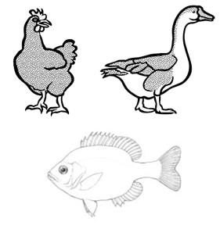Ducks and fish having different living space requirements, however the integration considers making the combination work well with linking fresh droppings into pond. Ducks and chickens have the same living space requirement. You may refer to duck and chicken manual for more details. Generally, one duck or chicken needs 1 square meter (1m2) of living space area and 3 fish (tilapia) will need one square meter (1m²) area of pond water. A fresh dropping from either a chicken or duck is able to fertilize about a minimum of 6 square meters of pond surface water. How does all this fit together?

|  |  |
| --- | --- |
|  | Working together 🡪 a little bit of math Imagine you have a pond that is 10m long and the shorter end is 5m. Your area will be about 50 square meters (10m x 5m = 50m²). From what we already know, you can do some simple math to know how many fish you need. We would need for our example 3 fish per square meter times 50 square meter is 150 fish   * How many ducks can we have in our imaginary pond?   Remember, 1 chicken or duck can fertilize 6 square meters of pond water. So 50m² meters divide by our fertilizer rate. How much ducks or chickens do we get? We get about 8 (8.33 to the nearest whole number) birds that can be used as part of the imaginary fish pond integration.   * How much house spacing do we need now?   If 1 bird is 1 square meter, that would mean we would need about 8 square meters of area space for our ducks or chickens.  **To summarise the steps;**   * Calculate your pond area and divide by the dropping rate   Remember 1 duck or chicken dropping fertilizers 6m2   * Once you know the number of ducks or chickens you need, build your house according to 1m2 of living space area |

|  |  |
| --- | --- |
| A few notes to consider on the integrated poultry house | |
|  | Good housing is important for ducks or chickens under any farming condition in PNG. Protecting your poultry birds from heat, cold or rainy conditions helps farmers in maintaining their stock.  Before building your poultry house look at what you have, where your pond is; does it have a fence or do you have live fencing? Is it near or far from the household? Does it have regular water supply for your fish. What materials do you need to start building your house?   * Keeping your poultry birds in a safe and secure location keeps them from being poached or theft. * Avoid building an integrated fish pond far from the household * Building your house can be built by simple bush materials like tree branches and tree barks, grass thatching for roofing and thatched walling using bamboos * Ducks and chickens need nest boxes, Consider a place in the house for putting your nest boxes not just space for living but for broody birds * The floors of the house need spacing to allow droppings to hit the pond directly below. Make sure that the spacing is not far, 3cm spacing is good to allow ducks or chickens to walk freely inside * Housing has to be over the pond or partly inside the pond to allow food spillage, manure droppings to mix with the water. * Poultry houses can also be placed inside the pond provided that ducks or chickens can have access back into the house for feeding   More details on housing and other topics relating to housing and husbandry practices can be found in the chicken and duck manuals. |

### Have a look at the pictures, what do you notice?

|  |  |
| --- | --- |
|  |  |
| Broody ducks in their next boxes located in the house. Notice the spacing of the floor | This integrated fish pond has steps for ducks and fencing surrounding the house |
|  |  |
| This unfinished poultry house as all its posts inside the pond and as good floor spacing | This house as part of its posts sitting on the bank of the pond while its other two posts are inside. There is also a widow for ventilation |

|  |  |
| --- | --- |
|  | Thinking together 🡪doing a simple design Getting us to think about how we can do the fish pond integration and observing others and their designs helps build confidence in doing our own design.  Look at the design below, looks complicated but simple. We will go through the process from planning to implementing  The pictures below showing the processing of building a pond integrated facility. However, bush materials are more preferred in this instance. As a demonstration, the picture gives you a clear layout on the process |

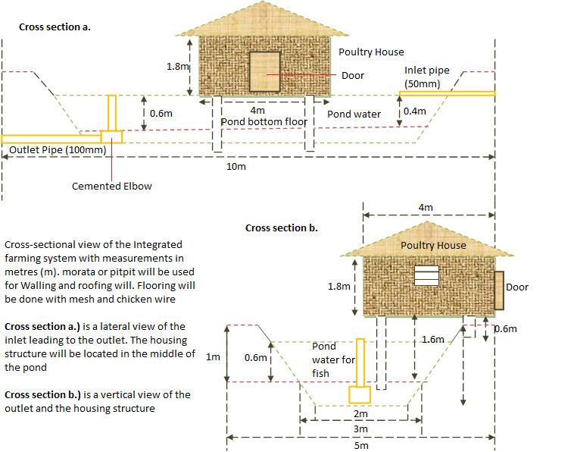

***Figure 14. Design of an integrated unit***

|  |  |
| --- | --- |
|  |  |
| 1. After selecting the pond, the pond is drained balance | 1. Posts are placed into the pond with the bigger part of the house over hanging the pond |
|  |  |
| 1. The house skeleton shows the over hanging of the pond | 1. The roofing goes first to keep the housing safe from the rain. |
|  |  |
| 1. The house taking shape | 1. The main living space for ducks or chickens |
|  |  |
| 1. Completed housing | 1. Inside of the house with nest boxes. |

|  |  |
| --- | --- |
|  | Working together🡪 what not to do Now that we see what we can do and have understood the planning process from the design to the implementation of the poultry house over the pond. Let us say we now have a fish pond integrated unit. A few notes to discuss on what not to do;   * Over stocking your integrated house may led to algae blooms – Stick to your dropping rates per duck or chicken * Never stock fry into an integrated pond unit unless you have chickens only. If you decide to put ducks, let your fry grow little more before placing them into your pond * Always have a wide walking plank or board for your chickens * Ducks love the water, practice bringing them out of the house early and luring them back in the afternoon for feeding * Ducks or chickens can be raised for meat and eggs, remember your female ducks or chickens are those that will sustain your integrated unit with ducklings and chicks * Always have saw dust or even dry grass in the nest boxes. Wet grass is bad for ducks or chickens |

Other big topic ideas like nutrition for your chickens and ducks, welfare, disease, husbandry are discussed in more details the ducks and chicken manuals.

# 

# Summary

Successful fish farm is a farm that has the following fish production stages;

1. A hatchery to manage breeders and fries
2. A juvenile production pond to manage juveniles and fingerlings
3. Grower production pond to manage young growers separated from male and female and are managed separately so they can obtain maximum growth
4. Breeder production pond to manage breeders and conditioned ready for breeding

Pond culture production of fish is the most cultured production system in Papua New Guinea and farmers that have a good planning for pond culture usually succeed in farming. The farmer must select a good site for pond construction; pond constructed must include hatchery, juvenile pond, grower pond and breeder pond. There must be good feeding system, breeding program and fish and pond management system to have sustainable and productive fish farming.

